Sri Lanka Institute of Information

Technology



Lab Submission

Lab sheet No 08

**IT24101727**

**Shanthoshika S.**

Probability and Statistics **| IT2011**

B.Sc. (Hons) in Information Technology

Question 1

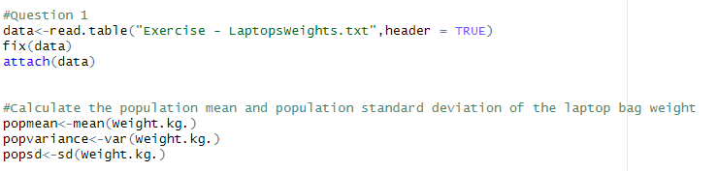

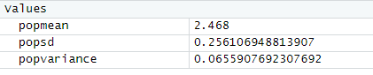

Question 2

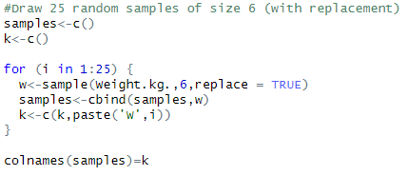

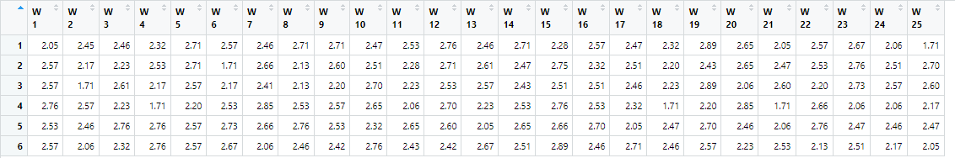

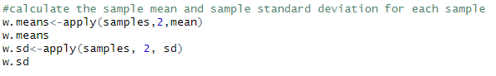

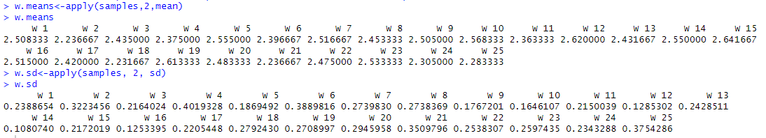

Question 3

